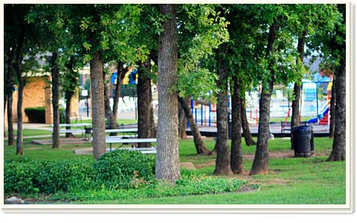**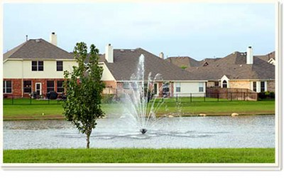VOWs**

Welcome to The Villages of Woodland Springs. We are pleased you have chosen this community as your new home! As a resident, you have the power to make an impact on your community.

**The Villages of Woodland Springs has many opportunities for you to use your special skill to enhance the community by serving on one of our many committees;** Safety Committee**,** Landscape Committee**,** Social Committee**,** Communications Committee,Pool Committee, and Budget, Finance, and Expenditure Committee.

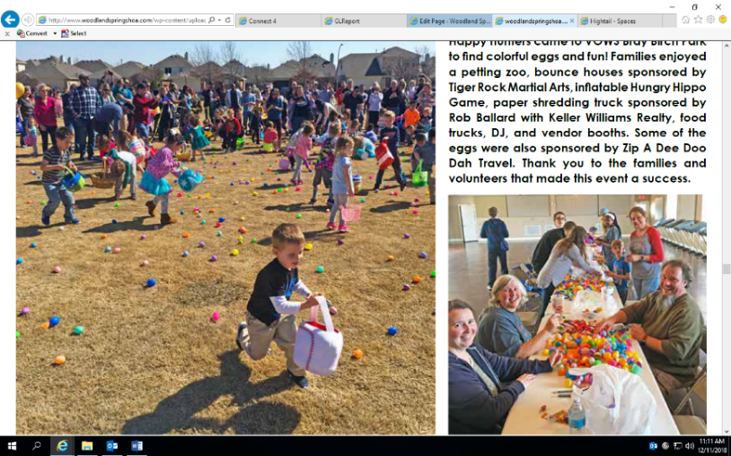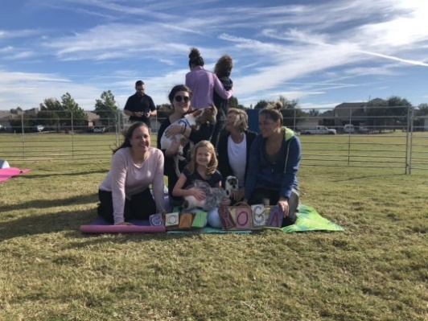**The Board of Directors consist of homeowner volunteers committed to making decisions that are in the best interest of the community.**

Tony DeVito**,** Juan Vazquez

Rachel Sanchez, Chad Pack

Chris Collins, Jim Houston

Nathan Watson

**The Villages of Woodland Springs has six pools, an amenity center available for rental, tennis, and basketball courts, a roller hockey rink, and numerous trails and ponds.**

To access the amenities, you will need to pick up a pool card at the main office located at

12209 Timberland Blvd., Fort Worth, TX 76244. This is also a great opportunity to meet the office staff.

**To stay up to date on events, and information regarding your neighborhood, we encourage you to attend monthly Board Meetings, and visit our website,** [**www.woodlandspringshoa.com**](http://www.woodlandspringshoa.com)**. You may also receive email updates by submitting your email to** [**vows.admin@fsresidential.com**](mailto:vows.admin@fsresidential.com)

**This is your community! If you see something concerning, such as maintenance issues, violations of the covenants, or safety issues please inform the office staff!**

**Office: 817-741-1719**

**After Hours Emergency: 877-378-2388**

**Craig Asaff, General Manager –** [**Craig.Asaff@fsresidential.com**](mailto:Craig.Asaff@fsresidential.com)

**Kirsten Croll, Assistant Manager –** [**Kirsten.Croll@fsresidential.com**](mailto:Kirsten.Croll@fsresidential.com)

**Claudia Lindsey, Lifestyle Coordinator –** [**Claudia.Lindsey@fsresidential.com**](mailto:Claudia.Lindsey@fsresidential.com)